“**Samurai Samuzai**” game concept

1. **One sentence game summary:**

* The game is about ancient legendary Japanese warriors, samurais. They used to fight with katana’s (a Japanese sword) while they were fighting demons or legendary creatures. I tried to represent that in this game.

1. **The story ‘narrative’ and setting:**
2. *Protagonist*: Ancient Samurai Warrior.
3. *Environment*: Temple mountains, Gango – ji.
4. *Task/Challenge*: Defeat Gagoze ( demon who attacked young priests at Gango - ji temple) and select the right path.
5. **Game Play – core features:**

* The game is won by defeating the NPC’s and selecting the right true path.
* User can score more points by collecting coins that are scattered over the maps.
* When a level is completed a “Success message” is show to congratulate the player.
* When a level is lost a “Failure screen” is shown to the player with an option to try again.
* If you collect a wrong food object, the player will lose lives.
* Lives are lost once the health bar goes down to 0. If the player picks up a “Health shield” the health bar goes back to 100%.
* Score cannot be lost unless the level is restarted or replayed.

1. **Possible additional game features:**

* The music can be toggled (On / Off).
* If the player presses “P” while in game mode, the game will pause and a pause menu with several choices will appear.
* Player Preferences can be deleted (reset) by using unity tools.

Gelmis S. Bartulis

B00080902

ITB Yr2 2015

5**. Annotated sketch of running game**

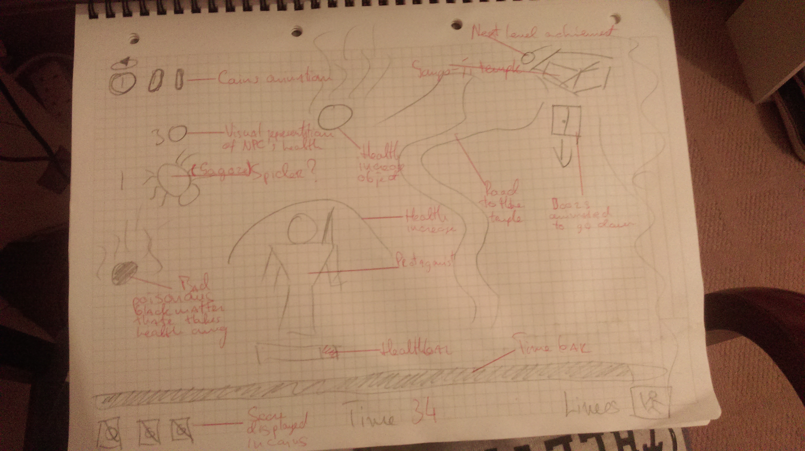

Gelmis S. Bartulis

B00080902

ITB Yr2 2015